Ideation phase
GARAGE MANAGEMENT SYSTEM
Brainstorm & Idea Prioritization

DATE | 1.11.2025
TEAM ID | NM2025TMID02770
PROJECT NAME | Garage Management system
MAXIMUM MARKS | 2 MARKS

GARAGE MANAGEMENT SYSTEM TEMPLATE:
The Garage Management System is a software application developed to manage the daily operations of a vehicle service garage efficiently. It helps in recording and tracking customer details, vehicle information, repair work, spare parts inventory, and billing in a systematic way. The system aims to replace the traditional manual process, which often leads to errors, data loss, and delay in service. By using this computerized system, garage owners can easily handle multiple service requests, monitor work progress, and generate accurate bills and reports. It also improves customer satisfaction by providing quick and transparent service. The Garage Management System ensures better organization, faster service delivery, and enhanced productivity, making it a valuable tool for modern automobile workshops.

STEP1: PROBLEM AND SOLUTION :
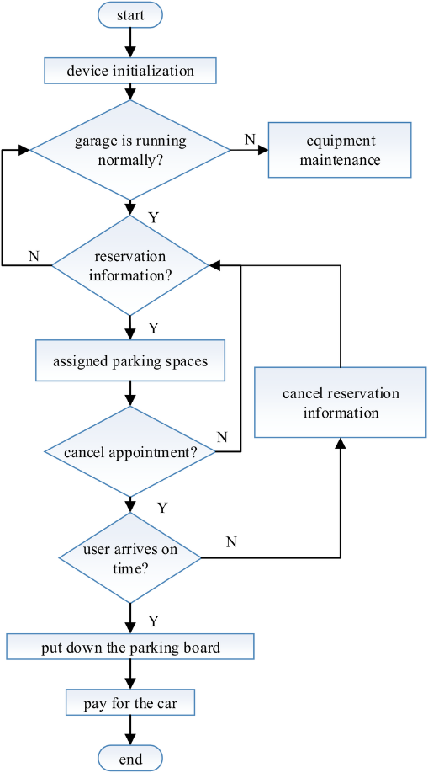
STEP2: BRAINSTRORM,IDEA LISTING AND GROUPING
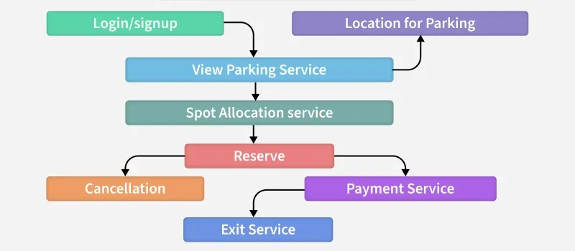

Brainstorm:
Team members collaborated to discuss common challenges faced by garages, such as manual record-keeping, missed service reminders, and inefficient job tracking. The session encouraged open sharing of ideas for automation, digital records, and user-friendly dashboards.
Idea Listing:
All ideas were listed, including service scheduling modules, mechanic assignment, spare parts inventory tracking, billing systems, and customer notification features. This ensured every suggestion was documented for further evaluation.
Grouping:
Similar ideas were grouped into categories like Service Management, Customer Management, Inventory, and Billing. This helped identify priorities and structure the development process effectively.
Action Planning:
The best ideas were converted into actionable steps — for instance, automating service reminders and integrating billing with job completion. Responsibilities were assigned to each team member, along with timelines for prototype development.

